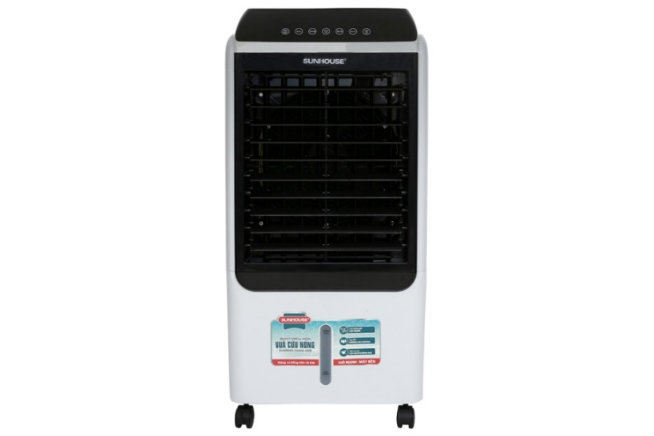

**3.990.000₫**

~~6.500.000₫~~ -38%

**Technical specifications of Sunhouse SHD7727 air conditioning fan**

* Cooling range:

Room 25 - 30m²

* Wattage:

150W

* Wind speed:

3 wind levels

* Control:

There is a remote included with Touch

* Highest noise level:

65 dB

* Water bottle:

40 liters

* Utilities:

Has moving wheels Has a cooling dry ice box Has a display screen Has a water level display scale Has a sediment discharge valve for the water tank Room temperature sensor Turn off timer Creates air purifier ions Automatically turns off the pump when water runs out Condition remote control

* Size, volume:

Width 50 cm - Height 105 cm - Depth 36 cm - 13.5 kg

* Brand of:

Vietnam

* Made in:

China

ntroducing the company 

- Vietnamese brand, with Korean joint venture capital in 2010.  
- Established in 2000.  
- Known to the majority of users with more than 450 product groups of household electrical appliances and household appliances such as gas stoves , electric stoves, pots, pans, rice cookers, electric kettles...  
- Sunhouse's products win the hearts of Vietnamese people with affordable prices, guaranteed quality, diverse designs and models to meet the needs of customers. all users.

**Cool with 2   included**[**boxes of dry ice to help the fan cool down more effectively on hot days**](https://www.dienmayxanh.com/quat-dieu-hoa?g=co-hop-da-kho-lam-mat)

**Convenient design of separate dry ice box, helps increase cooling ability quickly**

**150W capacity to quickly cool a room area of ​​25 - 30m2 , suitable for living room, dining room, restaurant,...**

The main motor is wound with copper wire, the water pump motor is wound with aluminum wire, operating smoothly and durable. Besides, the negative ion generation function helps purify the air, bringing a fresh and clean space.

**Sunhouse steam fan is easy to move with 4 flexible wheels, 2 wheels have fixed locks to hold the fan firmly, avoiding moving or falling.**

**The noise level at 65 dB is equivalent to the sound of a soundproof movie theater, office, or quiet hotel lobby.**

[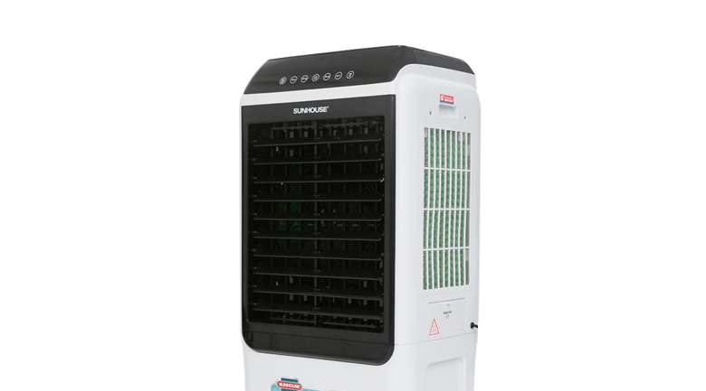](https://cdn.tgdd.vn/Products/Images/7498/199117/sunhouse-shd7727-kg1.jpg)

**Steam air cooling fan with large water tank capacity of up to 40 liters**

The water tank has a scale that displays the water level, helping to monitor the water in the tank, making it convenient to refill water. Equipped with a feature to automatically turn off the pump when water runs out. There is a valve to drain the water tank, making it convenient to clean the tank.

**The touch control panel has easy-to-understand and easy-to-use display lights and a room temperature sensor**

The fan has 3 customizable wind speeds and 3 selectable wind modes: normal wind, natural wind, and sleep wind. The sleep wind mode operates similarly to the natural wind mode but is quieter and hardly noticeable.

Users use the [shutdown timer](https://www.dienmayxanh.com/quat-dieu-hoa?g=hen-gio-tat) to protect the fan motor and especially health when using the fan at night, the maximum timer is up to 12 hours.

See more:  [How to use air conditioning fans](https://www.dienmayxanh.com/kinh-nghiem-hay/cach-su-dung-quat-dieu-hoa-831809) .

**The fan comes with a remote control that is very convenient to use**

The remote uses a small battery, convenient to replace when the battery runs out.

[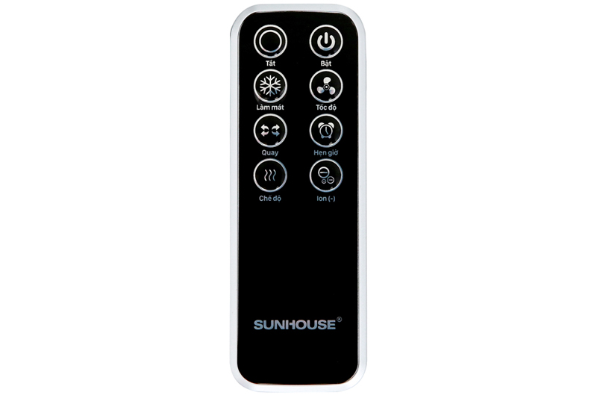](https://cdn.tgdd.vn/Products/Images/1992/199117/quat-sunhouse-shd7727-kg-7.jpg)

**Notes to  use**[**air conditioning fans**](https://www.dienmayxanh.com/quat-dieu-hoa)**effectively:**

- Air conditioner fans only have the ability to cool the air, not the cooling ability like an air conditioner.

- Placing a fan in the corner of the room will help the wind spread throughout the room, providing a natural wind flow that is good for your health.

- Place the fan at least 20 cm away from the wall so that the fan has space to get air.

- Clean the fan regularly and the water in the tank is clean to avoid bacteria from growing, causing odors and affecting health.

- [Sunhouse SHD7727 air conditioner fan](https://www.dienmayxanh.com/quat-dieu-hoa-sunhouse) has a wheel lock, so if the floor is slippery, you should lock it to keep the fan steady.

- You should add water before plugging the power cord into the power source. If you are using a fan, turn it off and unplug the power cord before filling it with water, then start it up and use it again.

- Unplug the power cord when not using the fan to save more electricity.

[Sunhouse SHD7727 air conditioning fan](https://www.dienmayxanh.com/quat-dieu-hoa/sunhouse-shd7727-kg)  is an effective cooling product for the family during the hot season.